**Fall**

14

**wesley.y.myers@gmail.com**

Weekly Status Report

Wesley Myers

November 25th – December 1st, 2014

08

**Fall**

Table of Contents

Executive Summary 3

Website Development 3

Serial Development 4

Physical Infrastructure 5

Appendix A 6

# Executive Summary

Website Development

* New webpage design and layout
* Error Checking

Serial Communicaiton

* Bad Analog Reads
* SoftwareSerial causing jitter
* Arduino Mega getting strange serial reads
* Good output on LightWare terminal

# Website Development

I went ahead and created a new website for the system. This system uses Bootstrap[1] for rapid website development. I also broke down the website to four web pages.

* Main: Video stream, pan-tilt controls, measurement capability, and centering.
* Targeting: Video stream, ability to see target list, clear target list, add a target, and verify targets.
* Stream: Just a video stream from the camera.
* Configuration: Shutdown and Reboot

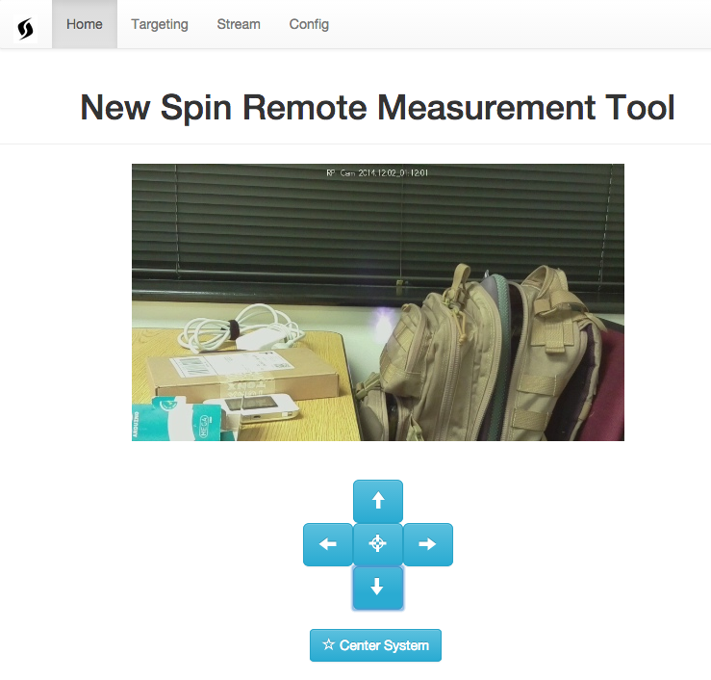

Figure - Main Page

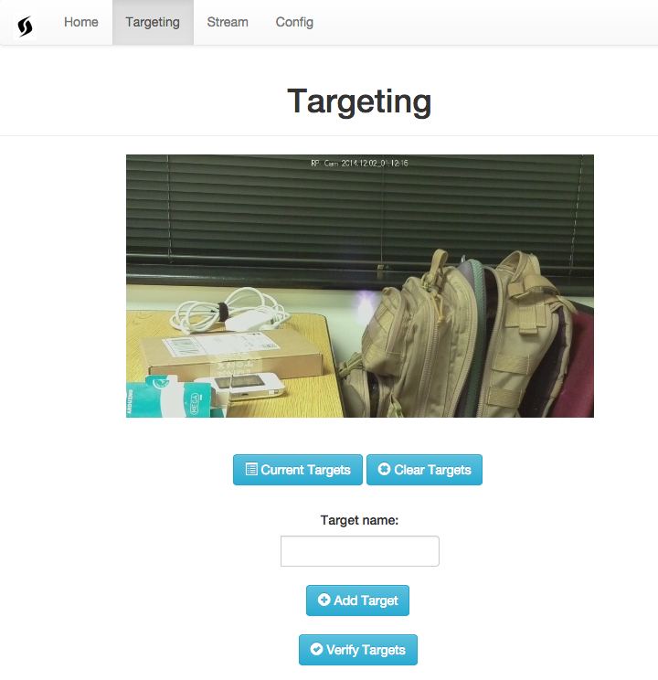

Figure - Targeting Page

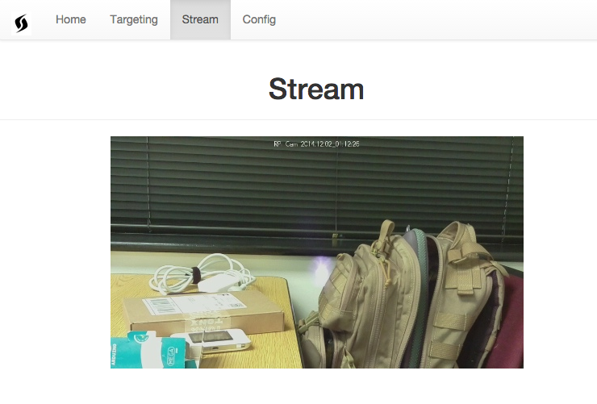

Figure - Stream Page



Figure - Configuration Page

In order to make targeting easier, I updated the Arduino script to return the servo position whenever a move is done. In addition, just in case there is a strange read exceed the 0-180 range read on the server side, the Arduino will just return the current servo position on request.

# Serial Communication

So there have been some headaches with getting good values from the LRF. At the moment, it seems almost random what the value will be. This is not useful at all.

The analog output seems to be jumping around a lot. No amount of filtering will be able to fix it. Due to this, I turned to trying to get serial communication back up and running with the LRF.

When SoftwareSerial was established with the LRF at a baud rate 115200 (specified in the manual), the servos started to jitter uncontrollably. After further discussion with Professor Houser, he said that SoftwareSerial will just simply not work at that high of a baud rate even though the Arduino Forms say it is possible. SoftwareSerial was probably eating up clock cycles that were being used for the servos, thus causing the jitter.

In order to debug this further, I grabbed an Arduino Mega and set up a simple serial test shown below.

void setup()

{

Serial.begin(9600); //computer terminal

Serial3.begin(19200); //LRF

}

void loop()

{

Serial3.flush();

Serial3.println("d"); //command to read

while (!Serial3.available()) { Serial.println("Waiting"); }

Serial.println(Serial3.parseFloat());

delay(5000);

}

This produced very strange results as well, which means to me that there might be a problem with the laser. Also, the baud rate of 19200 is not documented in the manual.

I went ahead and hooked up the LRF to the LightWare Terminal and the output appears to be just fine. It is a bit more jittery than it was before, but otherwise it seems fine.

Somewhere there is a flaw and I have yet to find it.

# Other

Early on in the semester, I went and added the ability to have the Pi search for multiple access points. I never documented it in my status updates. The following link is the source on how this was done.

<http://raspberrypi.stackexchange.com/questions/11631/wifi-setup-for-multiple-networks>

1. <http://getbootstrap.com/>